# **Module 9**

1. **For the following problem, define an ERD for the initial requirements and then revise the ERD for the new requirements.**

**Design Decisions:**

1. The Customer requests a set of tasks recorded by the work order
2. Thus the Customer can requests 0 or more work order ( crows foot near the ‘WorkOrder’ Entity)
3. A recorded work order has only on customer (A perpendicular line at Customer entity)
4. “Tasks are standardized across work orders so that the same task can be performed on many work orders and each task on a work order has a status”, hence an associative entity type of ‘WorkStatus’ with 1-M identifying relationship.
5. Each ‘WorkStatus’ has a mandatory work order denoted by perpendicular line near the ‘WorkOrder’

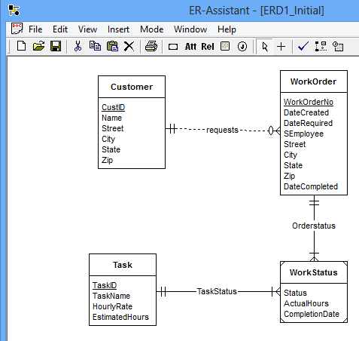

**Changes Made:**

1. Materials Entity is created
2. Each workOrder uses a collection of materials. Hence use an associative entity type of ‘MaterialDetails’ is added.
3. The estimated number of hours for a task depends on the work order and task, not on the task alone. Hence added to ‘WorkStatus’.

